1(A) LINEAR SEACH

C CODE:

#include <stdio.h>
#include <stdlib.h>
#include <time.h>

// Linear Search function
int linearSearch(int arr[], int n, int key) {
for (int i = 0; i < n; i++) {
if (arr[i] == key)
return i; // return index if found
}
return -1; // not found
}

int main() {
int n, key, result;
clock_t start, end;
double cpu_time_used;

printf("Enter number of elements (n): ");
scanf("%d", &n);

int *arr = (int *)malloc(n * sizeof(int));
if (arr == NULL) {
printf("Memory not allocated.\n");
return 1;
}

for (int i = 0; i < n; i++) {
arr[i] = i + 1;
}

)
key = n;

start = clock();
result = linearSearch(arr, n, key);
end = clock();

cpu_time_used = ((double)(end - start)) / CLOCKS_PER_SEC;

if (result != -1)
printf("Element %d found at index %d\n", key, result);
else
printf("Element %d not found\n", key);

printf("Time taken: %f seconds\n", cpu_time_used);

free(arr);
return 0;
}

PYTHON SCRIPT:

import matplotlib.pyplot as plt

n_values = [1000, 5000, 10000, 20000, 50000, 100000]
time_values = [0.00001, 0.00004, 0.00009, 0.00018, 0.00045, 0.0009] # in seconds

plt.plot(n_values, time_values, marker='o')
plt.title("Linear Search: Time vs Number of Elements")
plt.xlabel("Number of Elements (n)")
plt.ylabel("Time Taken (seconds)")
plt.grid(True)
plt.show()

PSEUDO CODE:

C Code:

Procedure LinearSearch(Array, n, key)
For i ← 0 to n-1
If Array[i] = key Then
Return i // Found at index i
End If
End For
Return -1
End Procedure

Main Program:
Input n
Create Array of size n
Fill Array with values (e.g., 1 to n)
key ← n

Start timer
result ← LinearSearch(Array, n, key)
Stop timer

If result ≠ -1 Then
Print "Element found at index", result
Else
Print "Element not found"
End If

Print "Time taken:", (Stop - Start)
End Program

Python code:

Import matplotlib library

Initialize list n_values = [1000, 5000, 10000, 20000, 50000, 100000]
Initialize empty list time_values

For each n in n_values:
Create an array of numbers from 1 to n
Set key = n (worst case)

Start timer
Perform Linear Search on array
Stop timer

Append (Stop - Start) to time_values

Plot graph with:
X-axis = n_values
Y-axis = time_values
Title = "Linear Search: Time vs Number of Elements"
Labels = ("Number of Elements", "Time Taken (seconds)")

Display graph
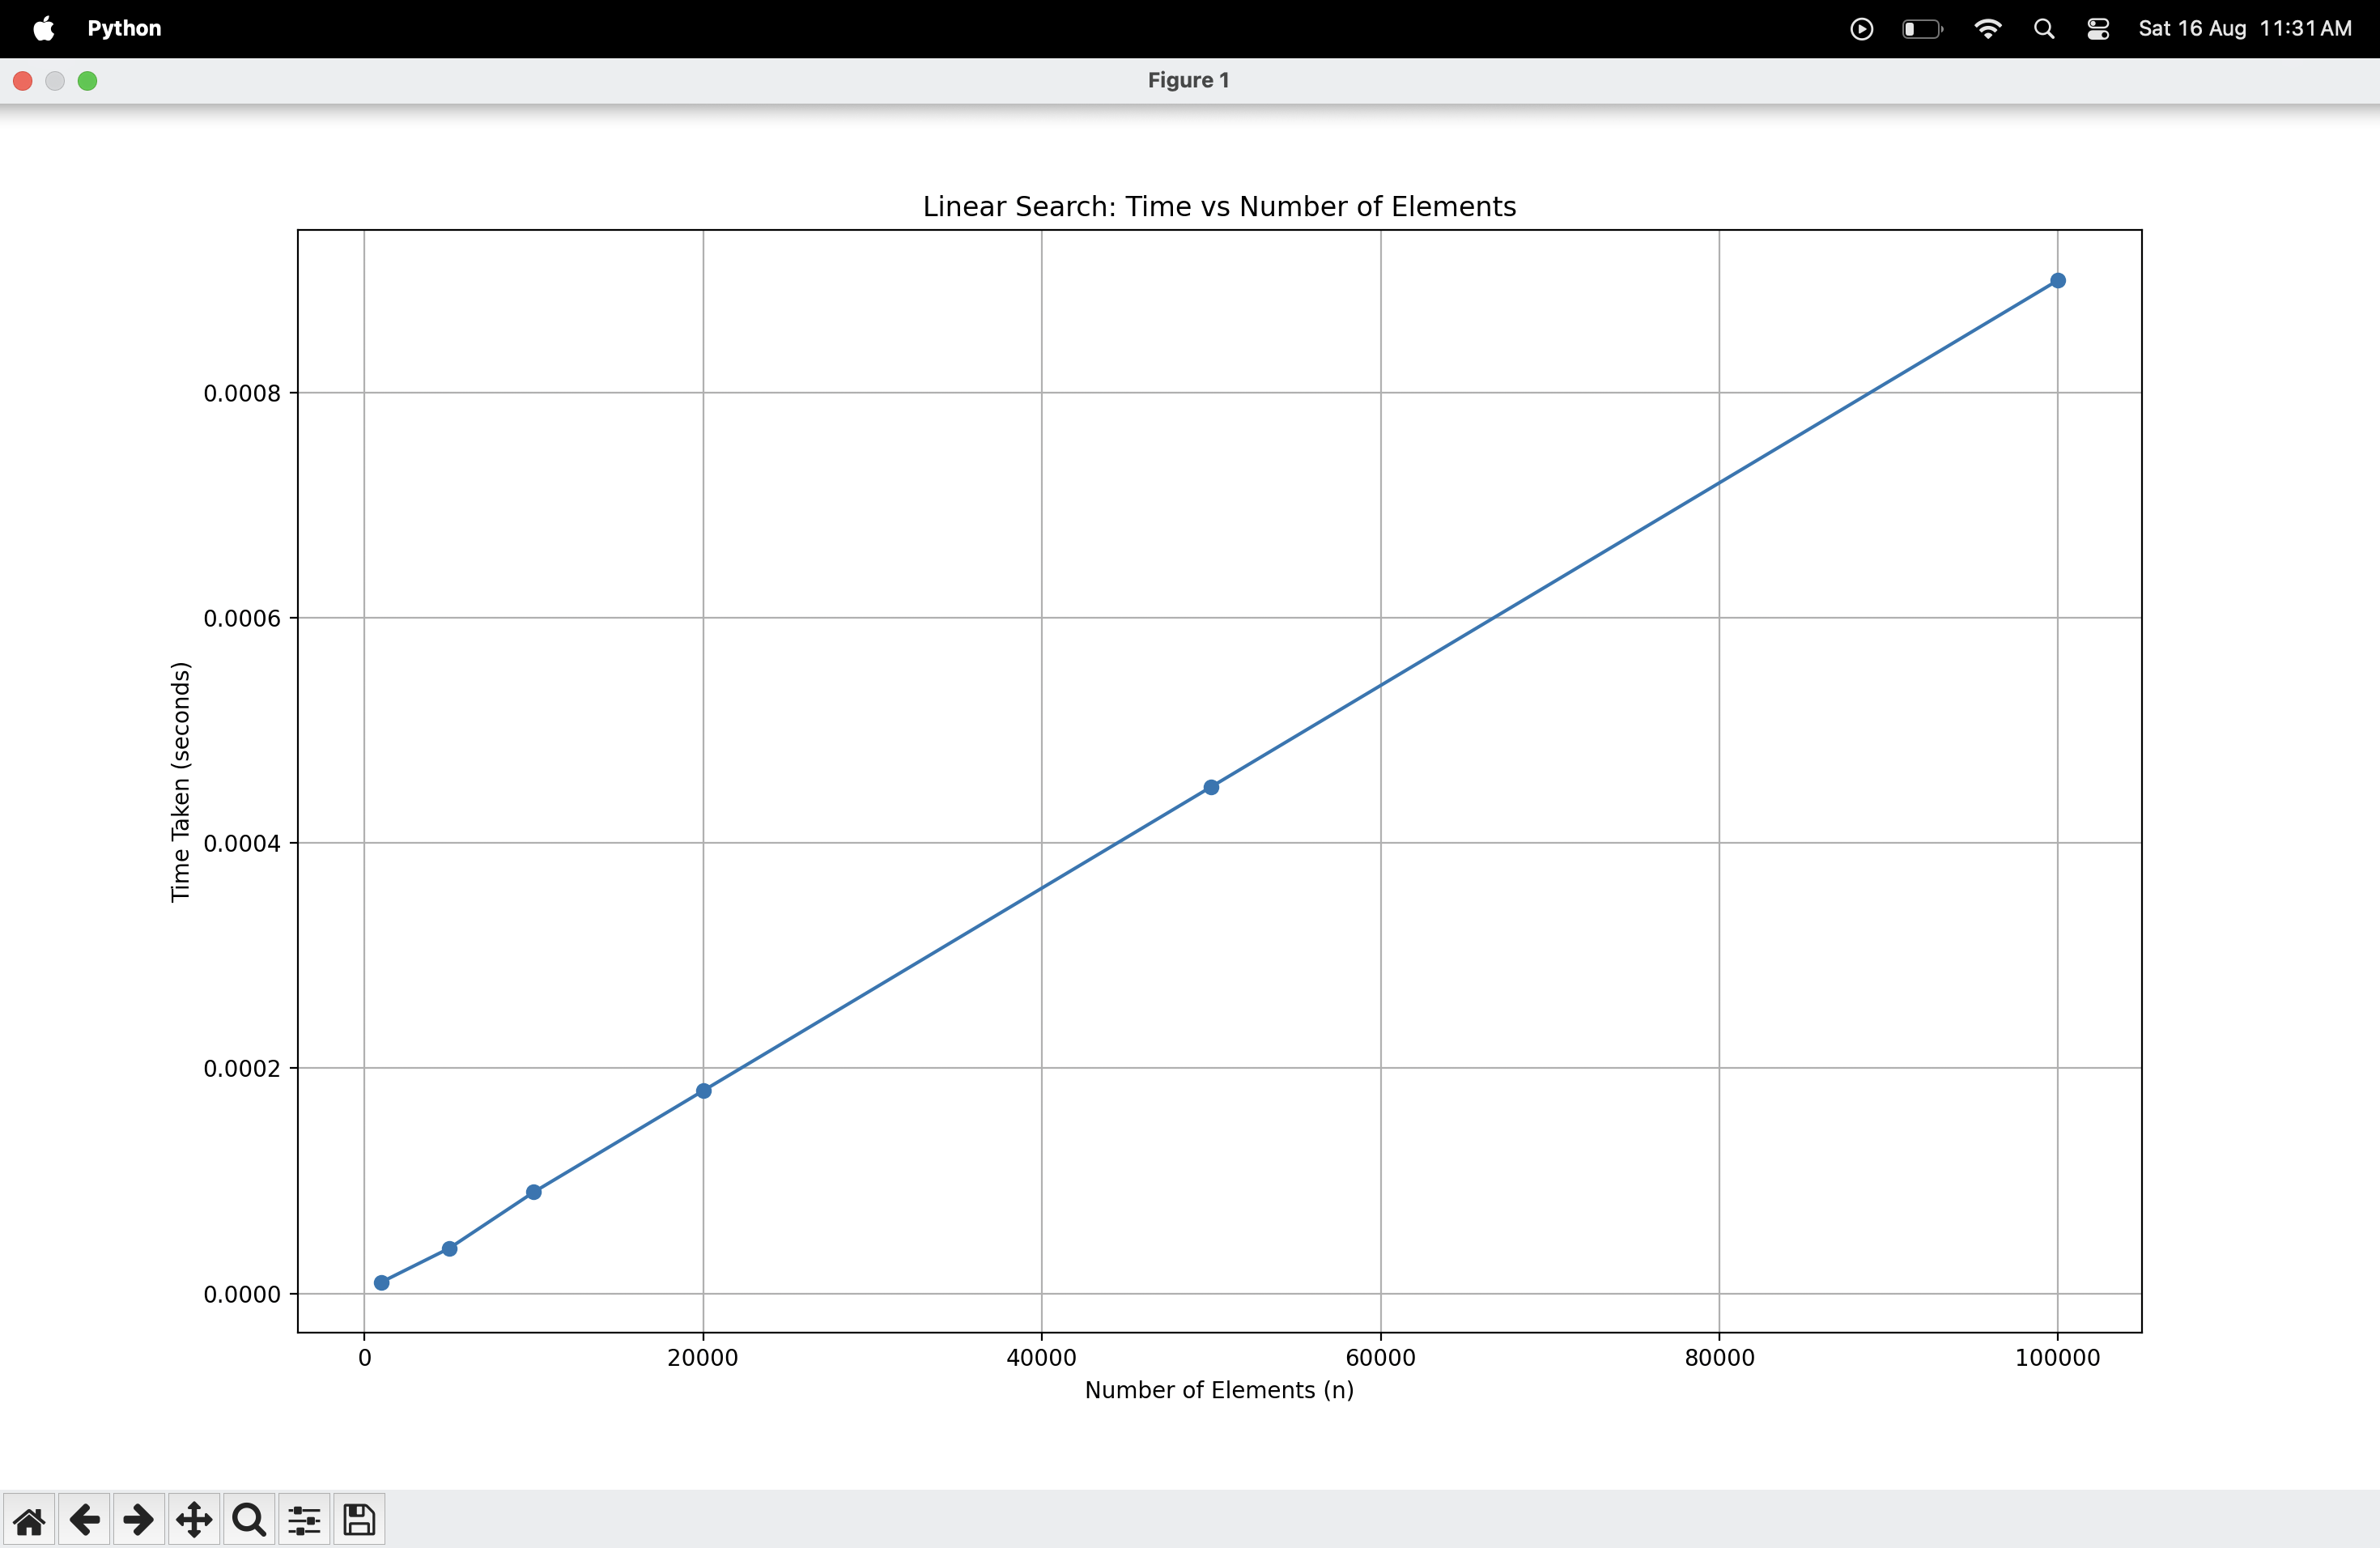

1(B) BINARY SEARCH

C CODE:
#include <stdio.h>
#include <stdlib.h>
#include <time.h>

// Binary Search function
int binarySearch(int arr[], int n, int key) {
int low = 0, high = n - 1;
while (low <= high) {
int mid = (low + high) / 2;
if (arr[mid] == key)
return mid;
else if (arr[mid] < key)
low = mid + 1;
else
high = mid - 1;
}
return -1;
}

int main() {
int n, key, result;
clock_t start, end;
double cpu_time_used;

printf("Enter number of elements (n): ");
scanf("%d", &n);

int *arr = (int *)malloc(n * sizeof(int));
if (arr == NULL) {
printf("Memory not allocated.\n");
return 1;
}
for (int i = 0; i < n; i++) {
arr[i] = i + 1;
}
key = n;
start = clock();
result = binarySearch(arr, n, key);
end = clock();

cpu_time_used = ((double)(end - start))

if (result != -1)
printf("Element %d found at index %d\n", key, result);
else
printf("Element %d not found\n", key);

printf("Time taken: %f seconds\n", cpu_time_used);

free(arr);
return 0;
}

PYTHON SCRIPT:

import matplotlib.pyplot as plt

# Example data (replace with your actual recorded values)
n_values = [1000, 5000, 10000, 20000, 50000, 100000]
time_values = [0.000001, 0.000002, 0.000003, 0.000003, 0.000004, 0.000004] # in seconds

plt.plot(n_values, time_values, marker='o', label="Binary Search")
plt.title("Binary Search: Time vs Number of Elements")
plt.xlabel("Number of Elements (n)")
plt.ylabel("Time Taken (seconds)")
plt.grid(True)
plt.legend()
plt.show()

PSEUDO CODE:

C CODe:

Procedure BinarySearch(Array, n, key)
low ← 0
high ← n - 1
While low ≤ high Do
mid ← (low + high) / 2
If Array[mid] = key Then
Return mid // Element found
Else If Array[mid] < key Then
low ← mid + 1
Else
high ← mid - 1
End If
End While
Return -1
End Procedure

Main Program:
Input n
Create Array of size n
Fill Array with values (1 to n) in sorted order
key ← n

Start timer
result ← BinarySearch(Array, n, key)
Stop timer

If result ≠ -1 Then
Print "Element found at index", result
Else
Print "Element not found"
End If

Print "Time taken:", (Stop - Start)
End Program
PYTHON CODe:

Import matplotlib library

Initialize list n_values = [1000, 5000, 10000, 20000, 50000, 100000]
Initialize empty list time_values

For each n in n_values:
Create sorted array of numbers from 1 to n
Set key = n (worst case)

Start timer
Perform BinarySearch on array
Stop timer

Append (Stop - Start) to time_values

Plot graph with:
X-axis = n_values
Y-axis = time_values
Title = "Binary Search: Time vs Number of Elements"
Labels = ("Number of Elements", "Time Taken (seconds)")

Display graph
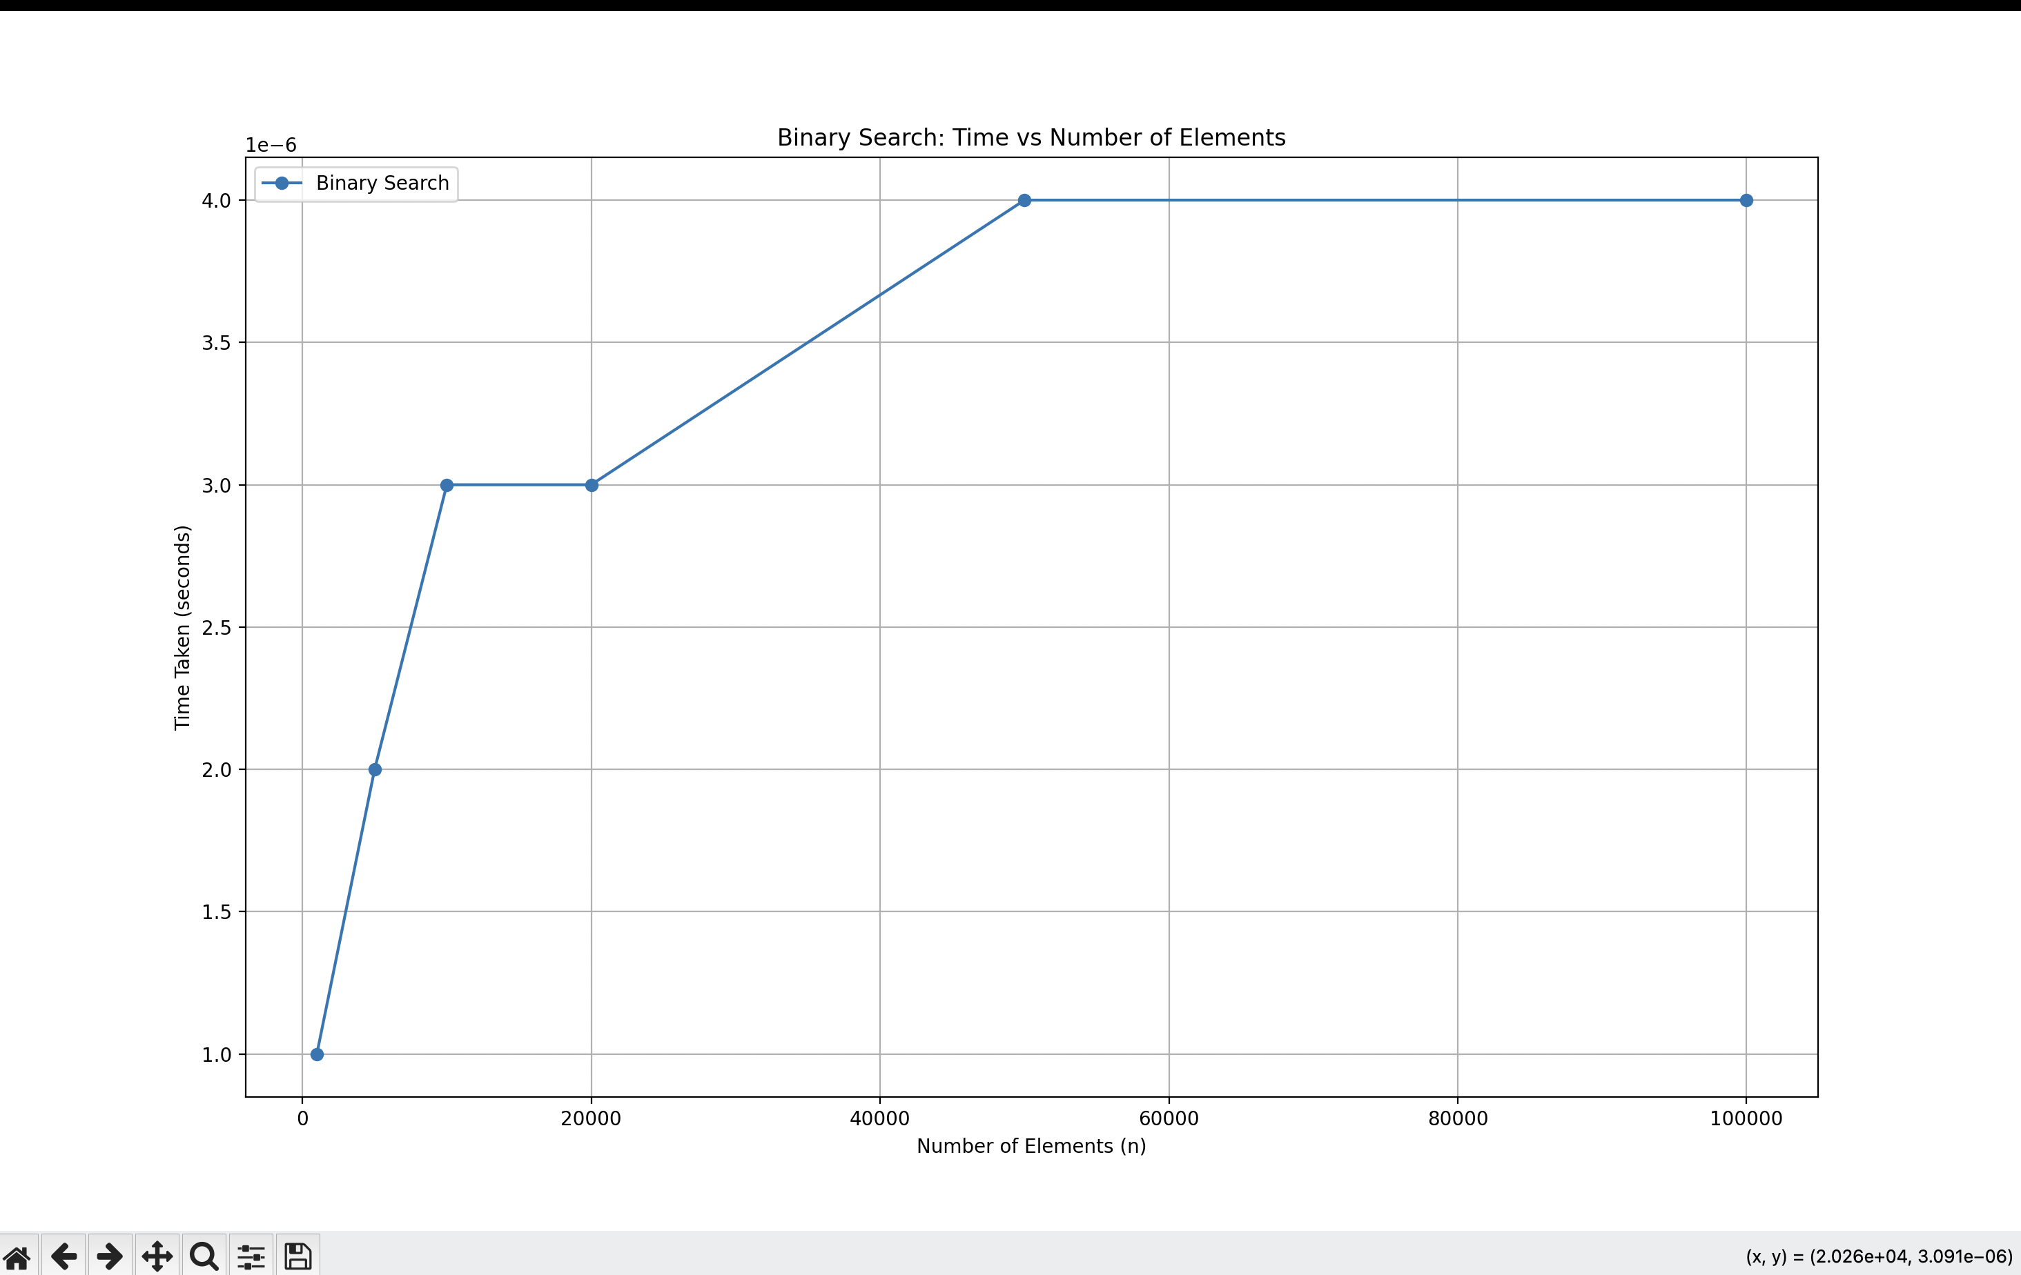

CONCLUSION:

From the two experiments, we clearly see a difference in how Linear Search and Binary Search perform as the number of elements (n) grows.
- Linear Search goes through each element one by one until it finds the target.
  - This means if the element is at the end, it will check almost the entire list.
  - The time taken increases directly with n (O(n)).
  - On the graph, the line keeps rising steadily as n gets larger.
- Binary Search works in a much smarter way.
  - Since the list is sorted, it keeps dividing the search space into halves.
  - This reduces the work drastically — even for a huge list, it takes only a few steps.
  - The time grows very slowly with n (O(log n)), almost flat in the graph compared to linear search.
🔹 What We Learn
- Efficiency matters – When the dataset is small, both searches feel equally fast. But as the dataset grows, linear search becomes slower, while binary search still remains quick.
- Sorted data unlocks better algorithms – Binary search only works on sorted lists. If we can arrange our data in order, searching becomes far more efficient.
- Theory matches reality – The experiment confirms what we learn in algorithm analysis:
  - Linear Search: O(n)
  - Binary Search: O(log n)

